**Metropolitan Ministries**:

As per MM portal, all of the user-stories which were approved in sandbox, are implemented on **sign-in** and **registration** page

**User-story # 3328** => MM => Forgotten Password not Working:

I have investigated this, it is working fine into dev and prod. For prod, detail is given below

We have a contact in CRM named zero bug, we are trying to reset his password.   
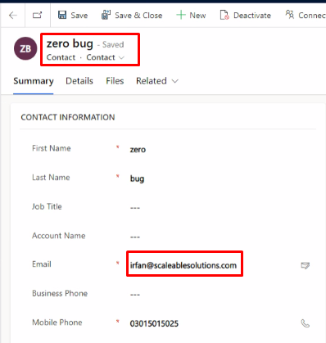

Here in portal, we use his email to reset portal account password

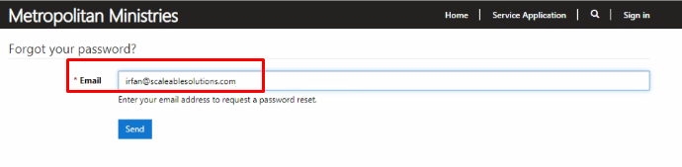

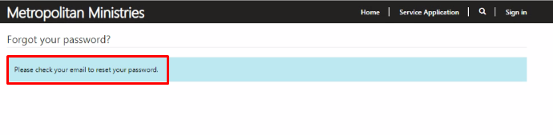

We received email for reset password

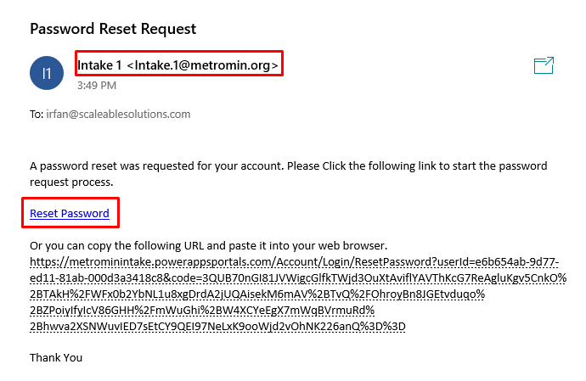

Now we can click on **Reset password** or either we copy the **below URL** for reset password**.**

Once click on reset password user will navigate to below link

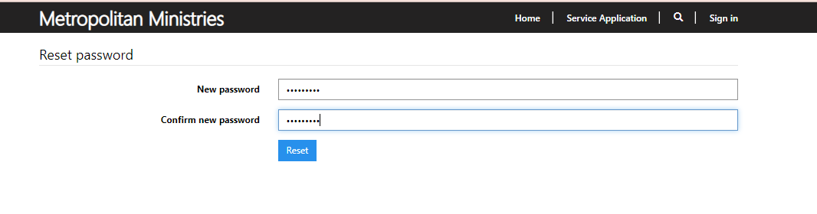

Once user click on reset,

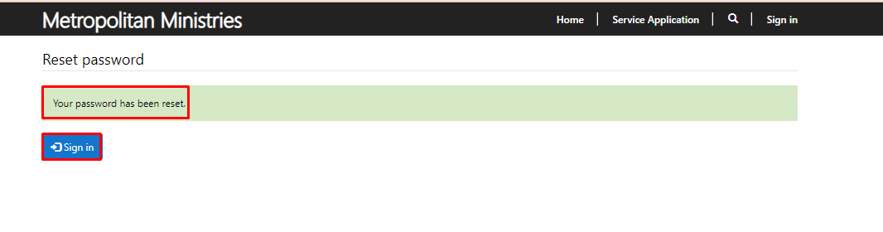

He can go to sign-in page directly to sign-in.

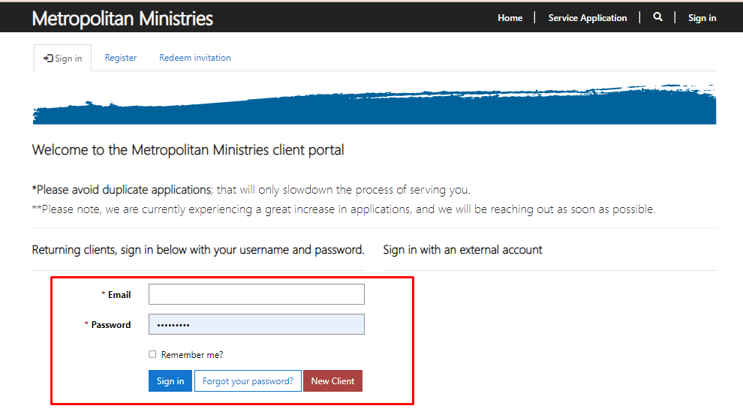

**User-story 2721**: MM: Create a flow to email contact, when application is in progress

Here I am going to change the status of my contact to **in-progress**

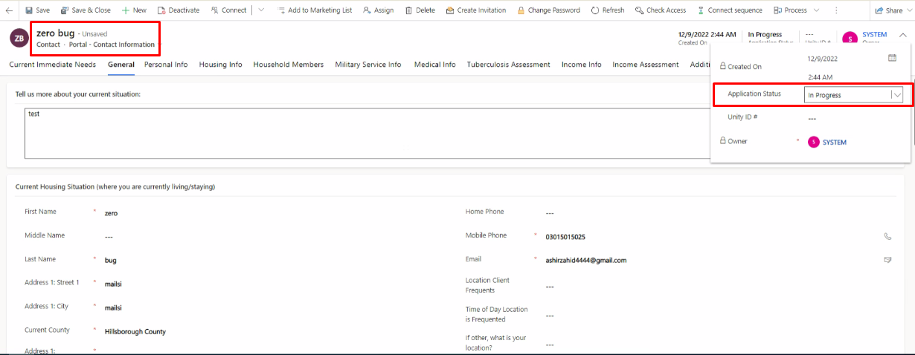

Once save: flow run

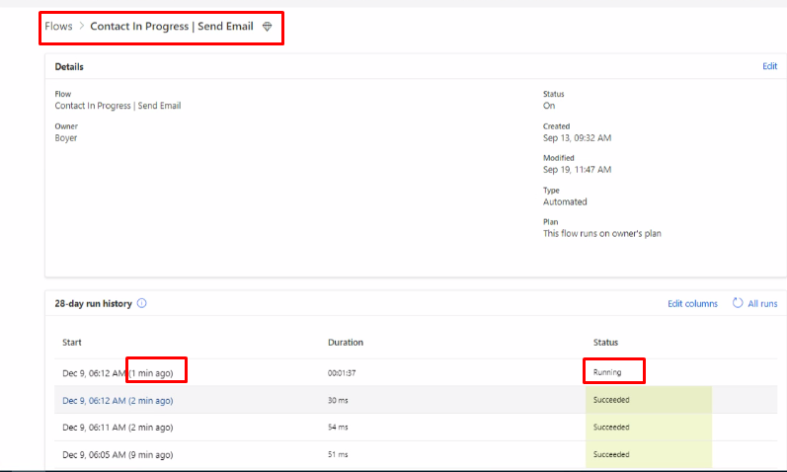

But flow is failed with error of 403.

We have investigated and came to know that flow is being failed on Production, as flow is having a delay of one day, after 24 hours all flow’s run history status is failed just because of mailbox is not authenticated and doesn’t have sufficient permissions because [intakedocs@metromin.org](mailto:intakedocs@metromin.org) is not have sufficient permissions.

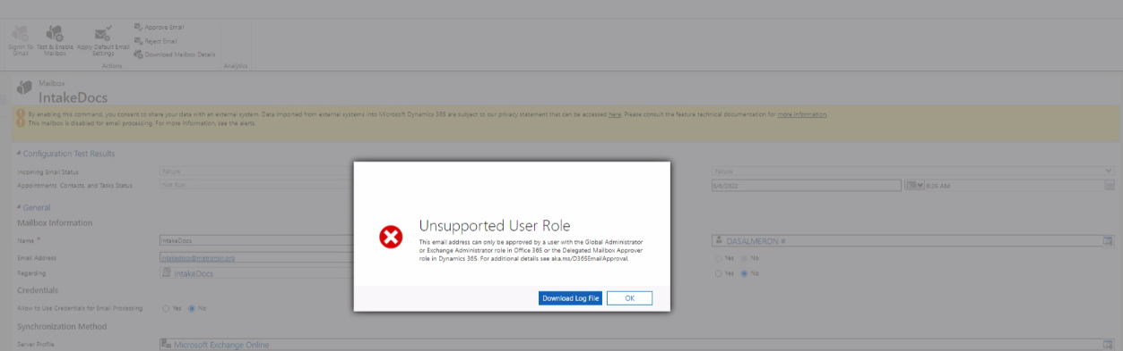

so, to prevent this, we add sending email on behalf of [Intake.1@metromin.org](mailto:Intake.1@metromin.org) and update the delay to 1 hour, but face error for this shared mailbox too.

So, need to authenticate [intakedocs@metromin.org](mailto:intakedocs@metromin.org) shared mailbox so that flow could send email to contact and **Boyer user in CRM doesn’t have permissions for this** [**intakedocs@metromin.org**](mailto:intakedocs@metromin.org) **mailbox**.

Below is the technical knowledge of error which we are facing:

A 403-error means that the account you are using within your Flow step does not have full permissions to the shared mailbox. Verify those permissions, specifically the send an email on behalf of the shared mailbox permission, and that should fix your issue.